Arduino
The Analytics ecosystem playbook.

Analytics ecosystem overview 3
Google Analytics 4 (GA4) 3
Segment 3
Microsoft Clarity 4
Shopify 4
BigQuery 4
Power BI 4
Looker Studio 4
Overall web analytics architecture schema 4
Data collecting, governance and data quality 6
Analytics and tracking documentation 6
Tracking guidelines and consent management 6
Cookie consent restrictions 6
User age restrictions 7
Browser and technology restrictions 7
Platform peculiarities and discrepancies 7
Google Analytics 4 (GA4) 7
Segment 10
Shopify 11
Data quality considerations 11
Slow or inefficient internal processes 11
Implementation errors 12
Errors when implementing tracking on GTM 12
Errors when implementing dataLayers 12
How to choose the best platform according to the use cases 12
When to leverage Google Analytics 4 12
When to leverage Segment 13
When to leverage Shopify 13
When to leverage dashboards (Looker Studio/Power BI) 13
Enabling self-service analytics 14
GA4 14
Dimensions and Metrics 14
Limits 15
Standard reports and Custom reports (Exploration) 15
Standard Reports 15
Explorations 15
Data Thresholding 16
Attribution models 17
Model comparison 17
Attribution Models used in reporting 18
Segment 19
Traits 19
Audiences 20
Looker Studio 20

Analytics ecosystem overview
To ensure data-driven decision-making and a seamless flow of information across platforms, Arduino’s analytics team has established a comprehensive analytics ecosystem that integrates key tools and technologies. The key components of this ecosystem are Google Analytics 4 (GA4), Segment, Iubenda, Shopify, BigQuery, Looker Studio, Power BI, each playing a distinct role in tracking, storing, analyzing, and governing data. Together, these components allow capturing user interactions, centralize data management, visualize insights, and maintain compliance with privacy regulations, creating a robust foundation for business intelligence and strategic optimization.

Google Analytics 4 (GA4)
GA4 is a Google-owned analytics tool that tracks website and app traffic and user behavior (both anonymous and identified). When enabled, it seamlessly integrates collected data with other platforms across Google’s marketing ecosystem, providing a comprehensive view of digital performance.
Data collected in GA4 are daily exported in raw format within the Arduino’s data lake on BigQuery.

Segment
Segment is the Arduino’s Customer Data Platform. Its goal is to serve as a single source of truth for all user-generated data, both online and offline. Behavioral data collected on the Arduino’s website are ingested in Segment, in real-time, enabling the creation of user profiles that are enriched with data coming from several other sources such as: Hubspot, Intercom, Zendesk and backend services ingesting orders and subscriptions data. User profiles can be activated creating audiences and pushing them throughout several destinations connected downstream such as: Linkedin, Facebook, TikTok and Google Ads remarketing lists, SMS and emails.
Data collected in Segment are daily exported in raw format within the Arduino’s data lake on BigQuery.

Iubenda
Consent management on Arduino’s website is handled through the Consent Management Platform: Iubenda.
The tool allows:

- Users to grant or deny consent for the storage of information (cookies) about their behavior.
- Communicating users’ consent choices to the measurement system.
- Ensuring that users can withdraw their consent at any time.
- Ensuring that Google and third-party tags comply with users’ consent preferences

Microsoft Clarity
Microsoft Clarity is a user behavior analytics tool particularly useful to understand how visitors interact with their sites by means of:
- Session recordings: Clarity records anonymized user sessions so you can watch how real users navigate, scroll, and click through the site.
- Heatmaps: It automatically generates click, scroll, and movement heatmaps showing which areas of each page get the most interaction.

Shopify
Shopify is the backend platform over which the Arduino Store environment has been built. It is worth to be mentioned in this context because beside managing products, inventories, prices and payments, it provides its own analytics data in a similar way GA4 and Segment do. It also allows to activate collected data through integrations with lots of destinations such as Google Ads, Facebook, TikTok and many more.

BigQuery
BigQuery is the Arduino’s data lake. It belongs to the Google Cloud environment and allows to store and analyse huge amounts of data with excellent performance. This is the place where almost all the data produced in the Arduino's ecosystem is stored and it is the data source for almost all the dashboards.

Power BI
Power BI is a Microsoft owned business intelligence (BI) and data visualization platform that enables analyzing data, sharing insights, and making data-driven decisions. Power BI can be connected to a wide range of data sources and allows to have much more control over the data in respect to Looker Studio in terms of data transformations, data cleaning, data modelling and creating relationships between datasets.

Looker Studio
Looker Studio is a Google owned data visualization and reporting tool that allows creating interactive dashboards and custom reports using data from various sources, such as Google BigQuery, GA4 and many more.

Overall web analytics architecture schema
The following schema shows the data flows behind Arduino’s web analytics architecture.
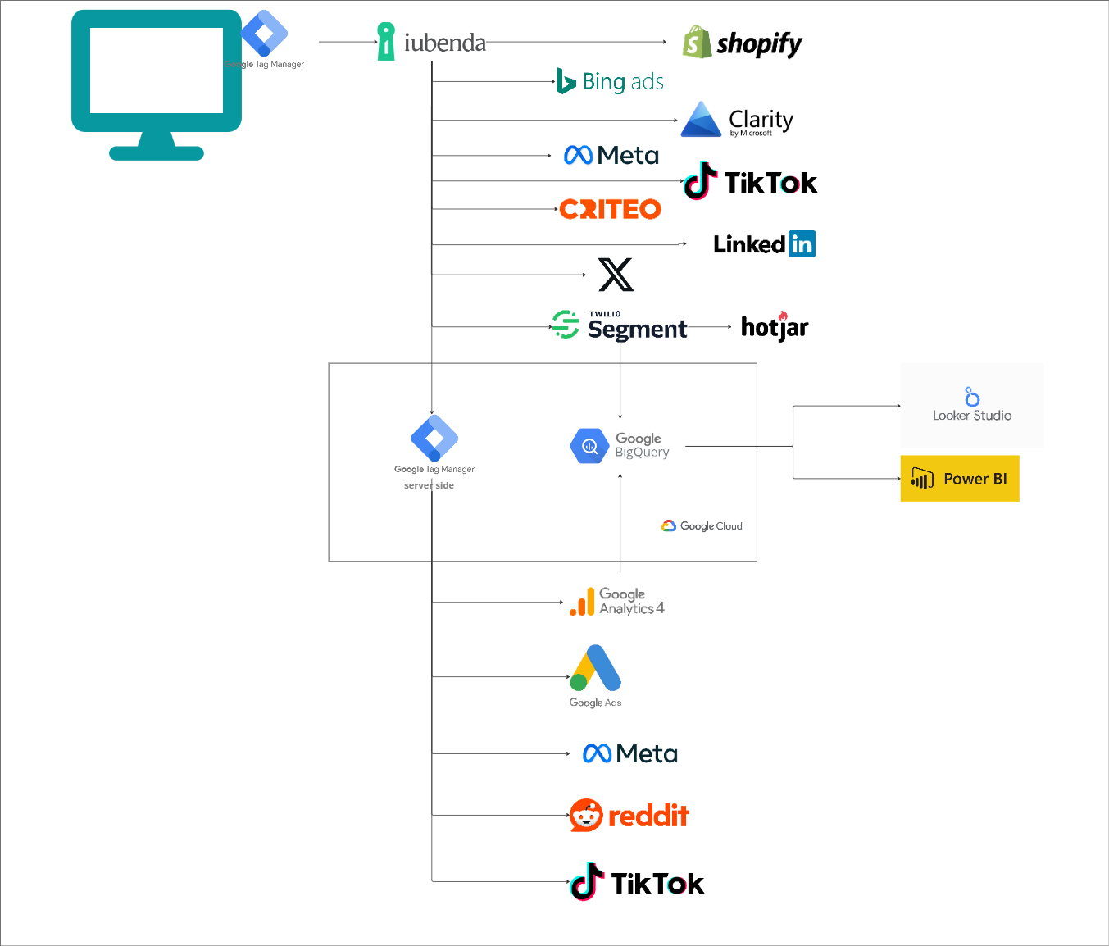
Here’s some deep dive on the data flows:
- Web data collection happens by means of the Google Tag Manager (GTM) utility deployed on the entire website.
- GTM is responsible for collecting real-time user behavioral data (e.g. page views, adds to cart, clicks, purchases, … ) and dispatching them to all the analytics and marketing destinations via 2 possible data flows: client side and / or server side.
- GTM has been configured in order to track only users with proper consent according to the GDPR, ePrivacy and internal Arduino’s guidelines (see next chapter for more information about this topic).
- The analytics platforms such as GA4 and Segment export their data within the data lake on Google BigQuery.
- Data residing on Google BigQuery can be consumed for analysis and dashboards by means of tools like Looker Studio and Power BI.

Data collecting, governance and data quality
In this chapter we highlight the main data collection and management aspects that may influence the way numbers are presented in the dashboards, within the tools’ interfaces and/or extracted to support ad hoc analysis.

Analytics and tracking documentation
Here’s some useful links to find out about tracked events, properties and naming conventions used.

- Segment Tracking Guidelines
- GA4 Tracking Guidelines

Tracking guidelines and consent management
According to the Arduino’s Privacy & Cookie Policy, across the entire web ecosystem, users can be tracked according to a specific set of rules which include 2 main restrictions:
- Cookie consent restrictions
- User age restrictions
Additionally, we also need to account for browsers and technology restrictions which further limit the amount of information that can be tracked on the web.

Cookie consent restrictions
Users can be tracked for analytics purposes only if they provide explicit consent to Measurement cookies. The choice is presented to users by means of the cookie banner loaded on the website provided by Iubenda.
If a user doesn’t grant consent it will not be tracked. This means that:
- Google Analytics is not going to track the user*
- Segment is not going to track the user
- Shopify is not going to track the user
- Microsoft Clarity is not going to track the user

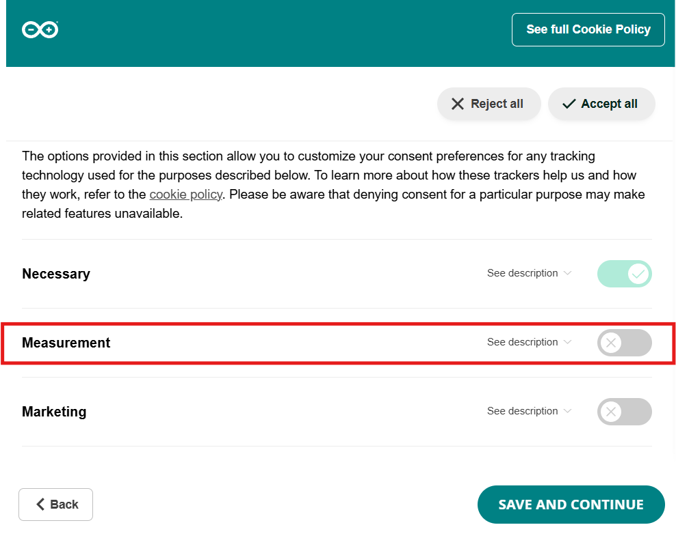

* Google Analytics has been implemented according to a specific set of rules, that even in case of a lack of consent from a user, allow to send anonymous pings that are modelled from the platform and then presented in the GA4 interface trying to reproduce the real traffic volume on the website. See next chapter for more information about this.

User age restrictions
Tracking of logged-in (authenticated) users identified as minors has been completely disabled, regardless of the cookie consent they provided.

Browser and technology restrictions
Please be aware that another aspect to consider when discussing online tracking is that these trackers may be further restricted due to browser-imposed limitations, device-imposed limitations and the presence of ad blockers on users’ devices.

For all the previous reasons, we need to be aware that the numbers we get from the Analytics platforms are never going to represent the exact picture of the overall traffic on the website, but they represent a subset of it with high statistical significance, thus useful to conduct analysis and extract insights.

Platform peculiarities and discrepancies
In this section we identify platform peculiarities in terms of data analysis, investigating both their interfaces and the possible discrepancies across the different tools.

Google Analytics 4 (GA4)
Google Analytics 4 allows switching between different kinds of reporting identities, thus dynamically adjusting the numbers within its interface depending on the one chosen. Here’s the different option at our disposal:
- Blended
- Observed
- device-based

The model set for the property can be seen and changed in the Admin > Data display > Reporting identity section.

Blended
Google Analytics leverages Machine Learning to model the behaviour of unconsented users (i.e. users who do not accept the Measurement cookie category on the banner) based on the behavior of similar users who accept analytics cookies. This is the way the platform allows you to gain useful insights from your Analytics reports while respecting users’ privacy.

In practical terms this means that from the GA4 interfaces we will be able to see an estimation of the real traffic of the website for some of the main metrics such as:
- Users
- New Users
- Sessions
- Conversion Rates
Here’s an example of the Acquisition overview report with Blended identity resolution set.
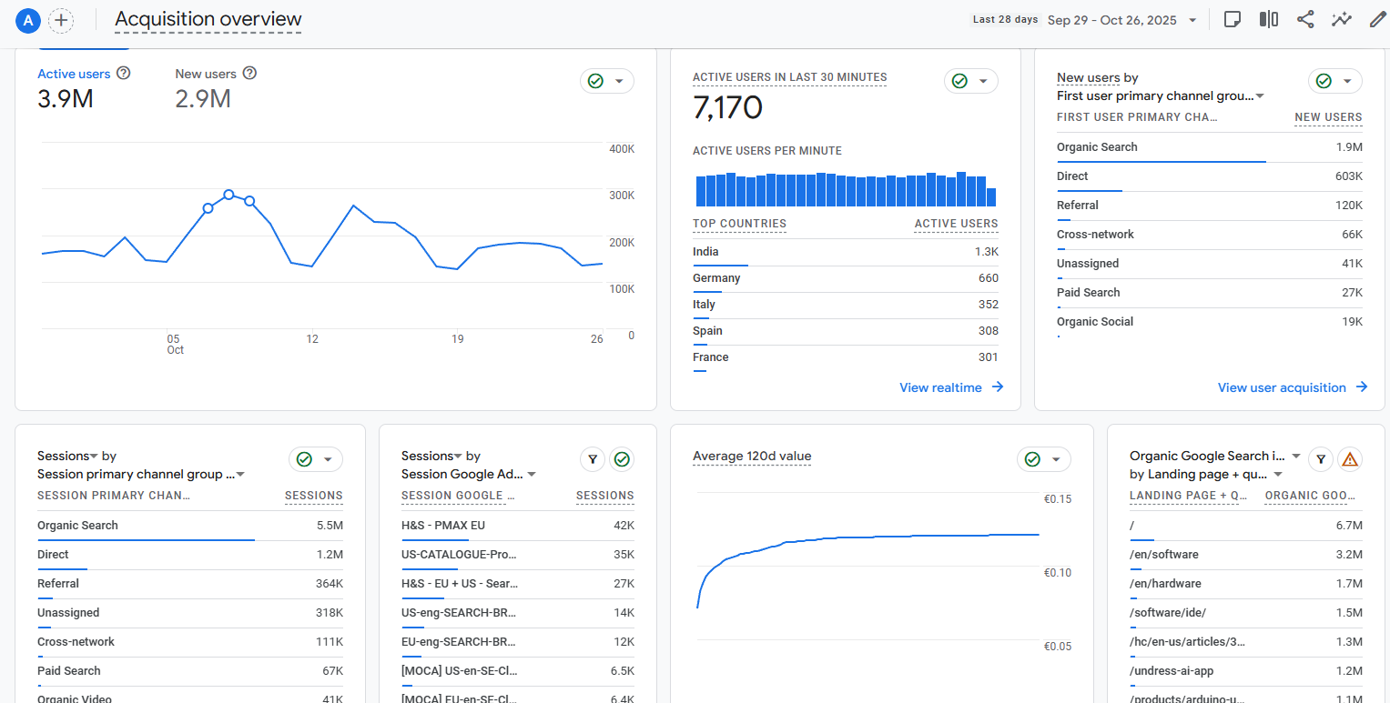
By clicking on the cards in the up-right part of the charts we can also see messages that confirm that numbers are being estimated or they warn when estimation wasn’t possible for any reason.
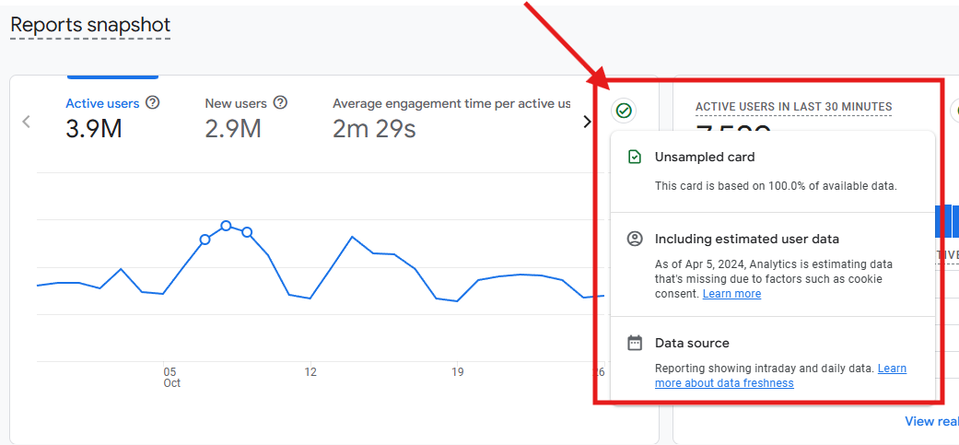

Observed
Google Analytics will only show traffic generated by consented users. Users can be identified from their Arduino’s User ID (if they log-in) and their Device-id (i.e. cookie id).

Here’s an example of the Acquisition overview report with Observed identity resolution set.
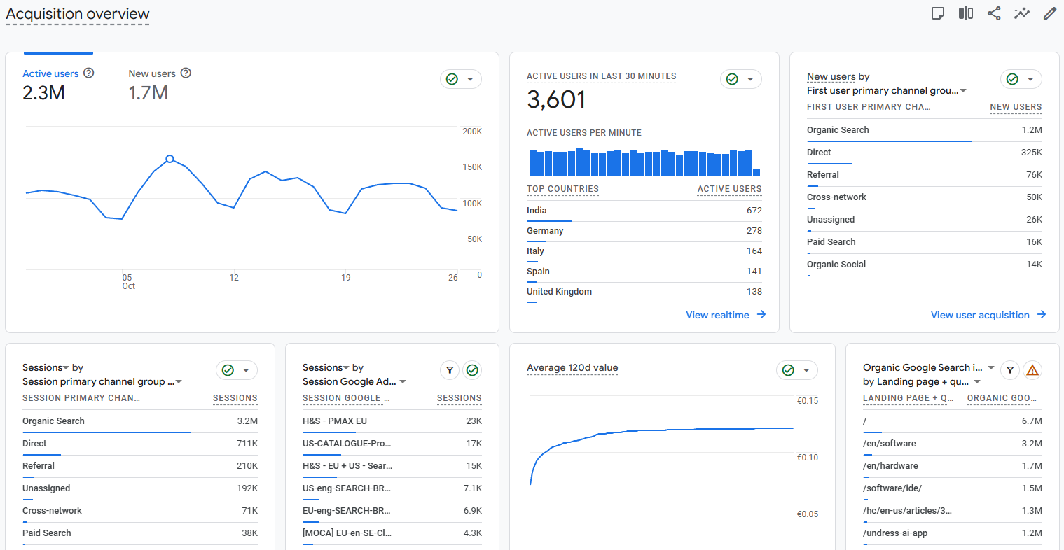
As it is possible to observe, numbers are almost halved. This is because here we can only see users that explicitly accepted to be tracked.
Having the possibility to rely on the Arduino’s User ID allows to reconcile traffic generated by the same user from different devices. For example:
- User A navigates on the Arduino’s website from their desktop computer and logs in
  - Device id: 1234567.122333
  - Arduino’s User id: 567
- User A navigates on the Arduino’s website from their smartphone and logs in
  - Device id: 2467382.998365
  - Arduino’s User id: 567
Thanks to our Observed reporting identity we are able to count the user as 1 since we reconcile the Arduino’s User id.

Device-based
Google Analytics will only show traffic generated by consented users. In this case only anonymous identifiers are going to be considered, thus only Device-id (i.e. cookie id) will be used.
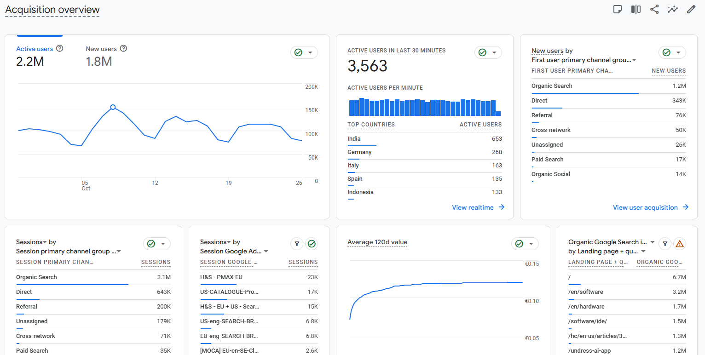
In this case we expect to see an inflated number of users, since there will be no reconciliation with their logged-in identifiers.
Let’s take the same example as before:
- User A navigates on the Arduino’s website from their desktop computer and logs in
  - Device id: 1234567.122333
  - Arduino’s User id: 567
- User A navigates on the Arduino’s website from their smartphone and logs in
  - Device id: 2467382.998365
  - Arduino’s User id: 567

By using the Device-based identity resolution method user A will be counted twice because the Arduino’s User ID is not going to be considered.

Segment
Data tracked with Segment can be compared to the ones observed through the Observed reporting identity method from Google Analytics 4. Actually we can say that Segment allows us to benefit from an improved version of the Observed reporting identity method since it is even more reliable in terms of stitching user identifiers.
We can say that Segment is much more precise in recognizing and building user profiles than any other platform.
This happens because Segment exploits more user identifiers, such as:
- Arduino’s User ID
- Email
- Device ID
- Shopify US ID (an identifier provided by Shopify on the US Store)
- Shopify EU ID (an identifier provided by Shopify on the EU Store)

Additionally, we can also assume that Segment is able to track a bit more users than GA4 because it is generally much less targeted from anti-tracker mechanisms on browsers and ad-blokers.

Shopify

COSA DICIAMO DI SHOPIFY?
NON ABBIAMO MAI SMARCATO VERAMENTE IL PUNTO LEGATO AI TRACCIAMENTI CHE SEMBRANO TRACCIARE TUTTI NONOSTANTE IL CONSENSO

Data quality considerations
In this section, we outline the main factors and concerns that may affect the quality of data gathered through the platforms.

As discussed in the previous chapter, the accuracy of the signals we receive is already limited by elements such as cookie and privacy policy restrictions, as well as browser-based anti-tracking mechanisms. These constraints are inherent by design and cannot be further mitigated.

However, there are additional circumstances that can sometimes compromise the integrity of our data collection pipeline, including:
- Slow or inefficient internal processes
- Implementation errors

Unlike the external limitations, these issues fall within our control and can be optimized or corrected to reduce potential disruptions in data collection.

Slow or inefficient internal processes
Internal processes sometimes can be inefficient, due to lack or delay of communications, misunderstandings, lack of a strategy phase.
This effects are generally the following:
- Features of our website not tracked immediately when released. This means we lose part of the data we should have been collecting.
- Features tracked without the necessary context to satisfy the real analytics needs

Implementation errors
Implementation errors need to be taken into account, although they should be minimized.
Implementation errors can be of 2 kinds, mainly:
- Errors when implementing tracking on GTM
- Errors when implementing dataLayers

Errors when implementing tracking on GTM
The GTM tracking activity is owned by the external agency Digital Pills. Whenever a new feature needs to be tracked, a request needs to be done to the Digital Pills team that is going to choose the best tracking approach. Generally, if the need is simple (e.g. know how many people clicked on a button) the implementation is quite fast and can be deployed in a very short time. If the need is a bit more complex (e.g. know the product variants mostly added to cart) then the Digital Pills team, before deploying the tracking, needs to involve Arduino’s development team in order to set-up a proper dataLayer event with the desired parameter as a context.
It happens that sometimes the tracking via GTM is misconfigured or it includes some errors.

Errors when implementing dataLayers
The dataLayer implementation activity is owned by the Arduino’s development teams
- Team 1 - store
- Team 2 - cloud
As previously mentioned, the dataLayer implementation activity is necessary when we need more context on the data we are collecting.
When involving the Arduino’s development team a ticket needs to be opened internally and we generally need to expect the activity is going to require some days before being completed. It happens that sometimes the dataLayers are misconfigured or they include errors, this of course can slow down the tracking phase.

Tracking misconfigurations have a strong impact on data quality and they might influence analysis and numbers displayed in the internal dashboards.

How to choose the best platform according to the use cases
Choosing the best data source is crucial to extract quality insights. Thus it is important to know when to leverage each platform.

When to leverage Google Analytics 4
Google Analytics 4 offers a user interface that allows to easily consume standard and personalized reporting. It is usually a good idea to leverage Google Analytics 4 when we need to perform standard user behaviour analysis.

When to leverage Segment
Segment is mostly used as backend source for dashboards since it provides more detailed events and user properties.

When to leverage Shopify
Shopify allows you to retrieve both traffic data and selling data. Usually we are not confident in trusting traffic data from Shopify since it has an automatic collection mechanism that cannot be fully controlled and audited. On the contrary, it is usually a good idea to extract KPIs related to item sold and revenues.

When to leverage dashboards (Looker Studio/Power BI)
Dashboards are the platform to use when I need to compile reports and/or extract insights related to KPIs and recurring topics. The answers to many of the recurring questions raised by stakeholders have been implemented and automated within the dashboards (such as the Cloud Business KPIs, EDU & Pro Plans, Users and subscriptions reports, etc.). When you look for interactive visualizations about Arduino data, Looker Studio and Power BI are the right place to look into.

Let’s try to summarize the main questions and topics that might arise when analyzing the data and see which platform is better suited to answer these questions.

Question | Platform
I need an estimate for the volume of traffic for the entire Arduino website in the last quarter and the split for each sub-domain (store, cloud, blog, etc..). | Google Analytics 4
I need to know the conversion rate for users coming from paid campaigns that added the new Arduino UNO Q to the cart. | Google Analytics 4
I want to build a dashboard showing traffic metrics for each of my domains | Segment
I need to perform an in-depth analysis of users who are actively using Arduino Cloud and they are also active on the blog. | Segment
I want to extract the main KPIs related to the sellings on the store. | Shopify
I need to know the number of free and paying users on Arduino Cloud during the past month, comparing it with the previous month. | Dashboard
I want to monitor the trend of MRR and paying customers for Arduino Cloud. | Dashboard
I want to see details of the organizations with an EDU or PRO plan. | Dashboard

Enabling self-service analytics
In this section we are going to give some hints on how to autonomously explore platforms and data by ourselves promoting a self-service analytics practice.

GA4
You can find at this link an Official Google Analytics Playbook.

Below some more details about:

Dimensions and Metrics

A dimension is an attribute of your data. It describes your data and it's usually text as opposed to numbers; dimensions provide context on your website or app’s performance.

Dimensions can be built-in or custom, and they have scopes (event, user, item) to define the level of the data they describe.

Example of GA4 dimensions:

- Demographics: Country, Continent, Age
- Device: Device Category, Device Brand
- Traffic Source: Session Source / Medium, First User Campaign, Google Ads Campaign
- Ecommerce: Item Brand, Item Category, Currency
- Events: Event Name, Transaction ID

GA4 has a wide range of predefined dimensions, but you can also create custom dimensions to track specific data points relevant to your business.

When creating custom dimensions, it is important to pay attention to the scope to be assigned (the scope determines the level at which a dimension applies).
Common scopes include:

  - User-scoped: attributes that apply to an entire user's journey
  - Event-scoped: attributes which measure details about user actions captured through an event
  - Item-scoped: attributes that describe a specific item (collected in the items array within an ecommerce event)

Metrics are quantitative measures; they allow you to count and measure dimensions. Metrics are usually numbers, which include costs, percentage, and time (e.g., sessions, number of total users, engagement rate, total revenue etc..).

You can also create custom metrics, as follow:

- Custom metrics: they enable you to analyze numerical values from event parameters. If an event parameter measures the quantity or frequency of an action, custom metrics transform those figures into actionable insights
- Calculated metrics: they enable you to combine one or more existing metrics and/or custom metrics to produce a new and potentially more valuable metric

Limits
The following table shows how many custom dimensions and metrics you can create for standard and 360 properties:
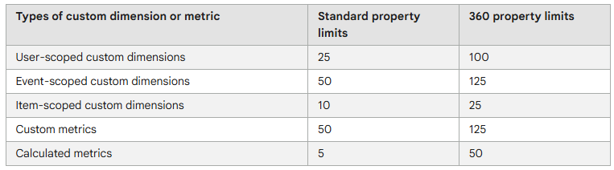

Standard reports and Custom reports (Exploration)

In GA4, both Standard Reports and Explorations are tools for analyzing your data but they serve different purposes and offer different levels of flexibility and detail.

Standard Reports
GA4 standard reports include the “Reports Snapshot” (a quick glance of performance without deep insight), the “Realtime” report, as well as “Life cycle” and “User” reports; the majority of the reports live in the “Life Cycle” area (Acquisition, Engagement and Monetization reports)
You can navigate to these reports by hitting the “Reports” button from the left-hand navigation.

Explorations
Explorations is a collection of advanced techniques that go beyond standard reports to help you uncover deeper insights about your customers’ behavior.
Some of these Explorations are pre-configured. Some are entirely new. There is also the ability to create a brand new Exploration from a blank canvas and pull in your own dimensions and metrics.
The main types of explorations in GA4 are Free form, Funnel exploration, Path exploration, Segment overlap, Cohort exploration, User lifetime, and User exploration. These techniques allow you to analyze user behavior with different visualizations and custom settings, such as a flexible, spreadsheet-like table (Free form) or a step-by-step breakdown of user actions (Funnel and Path):
- Free form: offers a flexible way to create custom reports with various visualizations like tables, line charts, bar charts, and pie charts. You can arrange rows, columns, and segments to analyze data side-by-side.
- Funnel exploration: visualizes the steps users take to complete a task or conversion, helping to identify drop-off points and opportunities for optimization.
- Path exploration: shows the paths users take through your site or app. You can see how users move forward from a starting point or backward from an ending point.
- Segment overlap: compares up to three different user segments to see how they overlap and identify similarities and differences in their behavior.
- Cohort exploration: groups users based on a shared characteristic or attribute and tracks their behavior and performance over time to understand user retention.
- User lifetime: explores user behavior and value throughout their entire lifecycle as a customer.
- User exploration: allows you to examine the individual users within your segments and drill down into their specific activities and journeys.
Explorations can be found immediately below the Standard Reports in the GA4 left-hand navigation.
It’s important to remember that GA4 only stores data in exploration reports for 14 months (the highest possible value) according to Arduino’s configurations. Data used in GA4 standard reports is retained indefinitely.

Data Thresholding
A related data availability topic is data thresholding in GA4.
Thresholding is when GA4 won’t show you some data because the user count is so low that you might be able to infer the identity of individual users based on demographic information and other signals.
Because of thresholding, data can be withheld from both explorations and standard GA4 reports. GA4 data thresholds cannot be changed. You can see if thresholding has been applied to your data because the data indicator icon changes to an orange triangle:
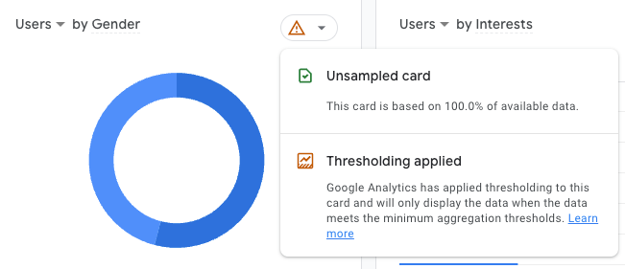
There are three instances when GA4 applies data thresholds:
- Google signals is enabled and the user count is low for the selected date range
- Your GA4 reporting identity relies on device ID and there aren’t enough total users
- Your exploration or standard report includes search queries and there aren’t enough total users.
You’re more likely to encounter data thresholds when using a narrow date range, so try expanding the date range and see if that helps.

Attribution models
Attribution in GA4 means attribution of traffic acquisition and conversions to the correct marketing channels so you can measure their performance.
Attribution models are based on a single rule, a set of defined rules, or an algorithm that decides which touchpoints should get the credit for conversions.
This means each model will have different results for the same conversion path.

GA4 has three types of attributions models:
- Data Driven (Paid and organic)
This is the default attribution model selected in GA4. it makes use of an algorithm to give credit to different touch points based on how they influence conversions.
- Last Click (Paid and organic)
This gives 100% conversion credit to the last touchpoint (non direct).
- Last Click (Google paid channels)
This gives 100% conversion credit to the last touchpoint (non direct).

The attribution model selected by default in GA4 is the Data-driven and compared to the other models, it makes use of an algorithm to give credit to different touch points.
The algorithm takes into account historic data from your account in terms of different touch points and combines it with AI modeling to give credit to each channel.

Model comparison
Model comparison is a great way to see how these models will attribute conversions to different touchpoints;
in GA4, you can find it under Advertising -> Attribution -> Attribution models

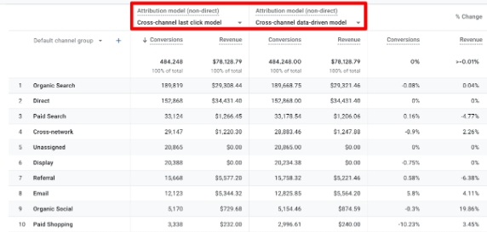

Attribution Models used in reporting
Within Standard Reports and Explorations different attribution models are used:

Standard Reports

- Acquisition -> User Acquisition report uses the first-click attribution model.
- Acquisition -> Traffic Acquisition report uses the last-non-direct-click attribution model.

Explorations
Within Explorations the attribution model depends on the specific dimension used in reporting. Here’s the most commons:
- Session default channel grouping / Session Medium / Session Source / Session Campaigns
These dimensions are session based and they use the last-non-direct-click attribution model. These dimensions are the one mostly needed.
- First user default channel grouping / First user Medium / First user Source / First user Campaigns
These dimensions are user based and they use the first-click attribution model.
- Default channel grouping / Medium / Source / Campaigns
These dimensions are event based and they use the last-non-direct-click attribution model. These dimensions are not so common to be used and they might be misused because they only show traffic that brought a conversion.

Segment
In this section we highlight the 2 main functionalities that might be useful to know from marketing and data activation perspective on Segment:

Traits
Traits represent user properties. Each user can be associated with a number of traits, such as age, gender, active plan, preferences, etc… Most of these traits are tracked and consolidated in Segment when the user navigates on the website with the proper consent, however it is possible to create additional traits from the Segment panel based on the data you possess. This functionality is called Computed Traits and can be found within the Unify section in Segment.

Computed Traits allow you to quickly create user or account-level calculations that Segment keeps up-to-date over time. These can be computations like the total_num_orders a customer has completed, the lifetime_revenue of a customer, the most_frequent_user to determine which user is most active in an account, or the unique_visitors_count to assess how many visitors from a single domain. These computations are based on your events and event properties that you are sending through Segment.

From an analytics perspective the most interesting Computed Traits are:
- Predictions
Predictions forecast the likelihood that users will take an action in your product and groups users with similar likelihoods together.
This might be useful for example if I want to target with an initiative only users that have a Predicted LTV greater than 300$.
- SQL
It is possible to write SQL queries directly executed on the data warehouse connected to Segment.
- Event counter
Count how many times each user has performed an event.
This might be useful for example if I want to target with an initiative only users that have purchased more than 1 product in the last 3 months.
- Aggregation
Aggregates properties into a single value.
This might be useful for example if I want to target with an initiative only users that have an avg. order size of at least 2 products in the last 30 days.
- Most frequent
Determine the most frequent property value of an event.
This might be useful for example if I want to target with an initiative only users whose top purchase category is home-automation.
- First
Show the value of a property of the first event seen.
This might be useful for example if I want to target with an initiative only users that have been seen for the first time 7 days ago.
- Last
Show the value of a property of the last event seen.
This might be useful for example if I want to target with an initiative only users that have been seen for the last time 1 month ago.
- Unique list
Show a list of the unique values of a property of an event.
This might be useful for example if I want to target with an initiative only users that saw a specific set of distinct products.
- Unique list count
Count how many unique values of a property have been seen for an event.
This might be useful for example if I want to target with an initiative only users that saw a specific product at least 5 times.

Audiences
Audiences can be found within the Engage section of the Segment panel.
Audiences are groups of people (also called profiles) with similar characteristics that depend on the configuration we decide to apply. For example, we might be interested in target audiences of people that have purchased at least a product within the last month or that access our website on a daily basis.
Segment offers an audience builder which is pretty straightforward and allows to create advanced audiences. In order to be able to that it is useful to know the naming convention for events and traits used in tracking.

Looker Studio
We will now see a brief overview on how to create a Looker Studio report from scratch, enabling self service analytics.
As a first thing, Looker Studio will ask you to add a data source to the report, in most cases will be a BigQuery table, a Google Sheet or a CSV:
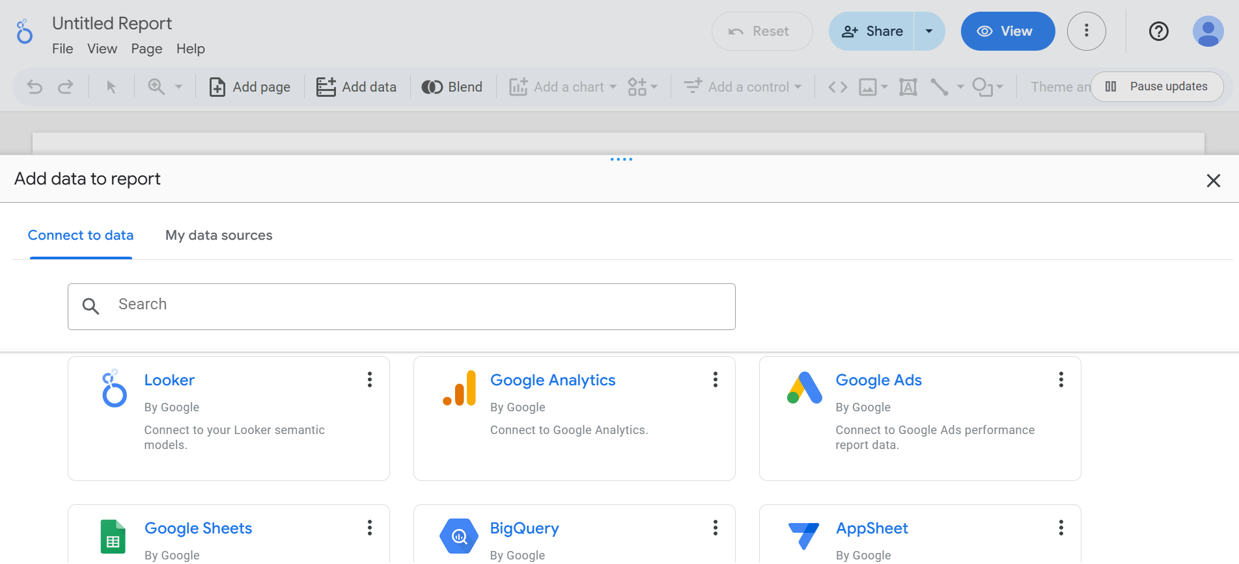
Next, we will be able to add a new chart to our blank page. Looker offers a pretty wide range of charts among which to choose.
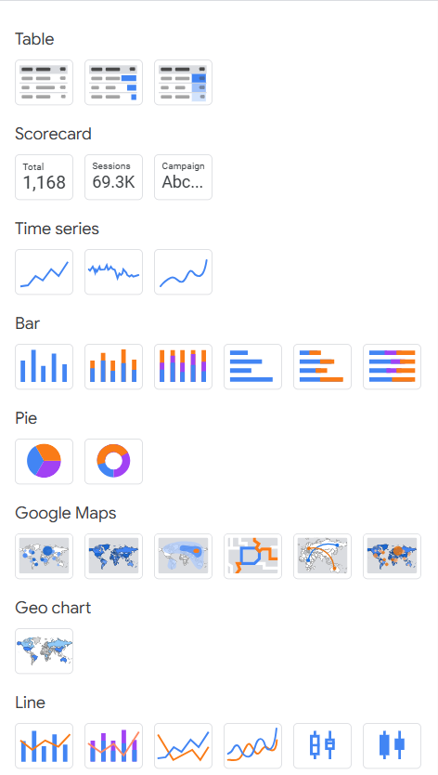
Whichever we choose, it will be necessary to configure it: clicking on it we will be able to choose the dimensions and metrics among the ones available in the data source. If necessary, we have the possibility to add a calculated field to the data source (see “Add a field” in the screenshot below); for example if in the source we have two metrics, sessions and purchases, we can add a custom field purchases/sessions, representing a conversion rate.
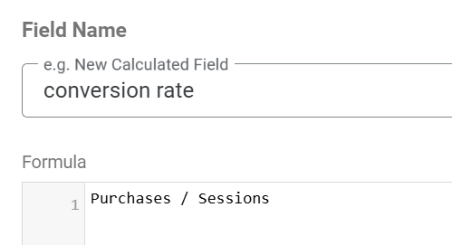

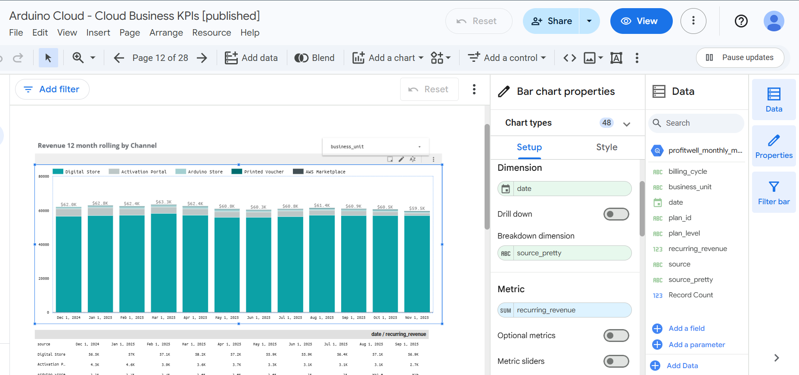

It is also possible to customize the style of the chart from the “Style” tab, modifying font, properties and colors.
As we can see from the screenshot, it could be useful to add some filters to the page, the most frequently used are Dropdown list and Date range control.

Power BI
Come pluggare power BI a data source (powerquery, extraction, ecc…)
Accessi bigquery in generale su tabelle

Iniziamo a draftarlo su confluence

